Software for Data acquisition services

Brief of requirement.
Software is required to display, edit and calculate the real time flow rates during production operation.
Data through USB will be transmitted to Laptop in Modbus file. Software is expected to acquire this data and display in P&ID, List view and graphical view.
Start up and configuration.
Data Capture for individual well production
- Client Name with option to add client logo
- Field name
- Well no.
Well History
- Well Drilled on (mm/yy) :
- Well completed on (mm/yy) :
- Work completion date :
- Type of formation : 100 words option
- Last operation performed – Should have 200 words space to write more details
- Well History – Should have 500 words space to write more details about the well.
Well Information
- Surface location : Lat / long addition option
- Drilling Rig Elevation: 50 words details.
- Production Casing details: 100 words
- Critical depth: 100 words
- Tubing details:
- Max. Deviation:
- Reservoir pressure:
- Reservoir temperature
- Last HUD: 50 words option
- Perforation Interval: 100 words option
- Pay zone:
- Minimum ID:
- Well Status:
- Option to add picture of well completion details
- Option to add well program (PDF File)
- Option to add Design of service (PDF File)
- Additional options to add additional relevant PDF file and naming them.
P&ID - Option to add Photo of P&ID or upload P&ID PDF that can be seen in the software when required.
List of Equipment and data from each equipment coming in the software
Sr. no. | Equipment | Sensors
 | Flow head / Well Head | 1 x Pressure  1 x Temperature
 | SSV Upstream | 1 x Pressure
 | SSV Downstream | 1 x Pressure
 | Well Head Desander | 1 x Pressure
 | Sand filter | 1 x Pressure for upstream  1 x Pressure for downstream  1 x DP Sensor
 | Data header Upstream of Choke manifold | 1 x Pressure  1 x Temperature
 | Choke Manifold | 1 x Pressure for upstream  1 x temperature for Upstream  1 x Pressure for Downstream  1 x temperature for Downstream
 | Data header downstream of choke manifold | 1 x Pressure  1 x Temperature
 | Indirect Bath Header | 1 x Upstream temperature  1 x Downstream temperature
 | Steam Heat Exchanger | 1 x Upstream Temperature  1 x Downstream temperature
 | 3 Phase Separator | 1 x Static Pressure  1 x Static Temperature  1 x Gas Temperature  1 x Gas Pressure  2 x Differential Pressure transmitter Gas line  1 x Gas flow meter  2 x Oil Flow meter  1 x Water flow meter  1 x Oil Temperature  1 x Level sensor 3 phase  1 x Level sensor oil chamber  1 x Water cut meter oil line
 | Surge tank | 1 x pressure  1 x temperature  2 x Level sensor
 | Knock out drum | 1 x pressure  1 x temperature  2 x Level sensor
 | Storage tank | 1 x Level Sensor  1 x temperature
 | Transfer pump Discharge | 1 x Pressure Discharge
 | Production Header | 1 x Pressure  1 x Temperature
 | 3 Way Manifold | 1 x Pressure  1 x Temperature
 | 5 Way Manifold | 1 x Pressure  1 x Temperature

The software should have provision to add above mentioned equipment from the drop down tab. It should have provision to select the serial or flow of the fluid by moving the selected equipment up or down. On selection of equipment, drop menu based on the sensor listed against each equipment should be seen.
Pressure
Flow head
Temperature

List of equipment and sensors should be developed using above methodology.
Once operator selects the sensor after selecting the equipment then configuration option to connect the modbus file to sensor option should be available.
Once list of equipment is finalized and sensors are connected to the modbus file then operator should have option to create P&ID and these sensor measurements should be seen on the P&ID screen.
Operator should be able to see the list view of each sensor’s live reading to confirm connection for all the sensor with software.
Operator can select the data from list view and move it to reporting file and based on that reporting file as given below shall be generated.

In the reporting file additional information acquired through external source needs to be added in the reporting file for different timelines.
Information that will be manually added shall be following.
- Density of Gas
- API Gravity of oil
- Water cut in oil line
- Choke Bean Size
- Orifice size
- Orifice meter line size (ID)
- Shrinkage factor for oil calculation
- Meter factor Water line
- Meter factor oil line
- Methanol injection rate and cumulative
- Defoamer injection rate and cumulative
- Additional chemical injection rate and cumulative
- Sand Quantity in KG
- Water PH
- Water Salinity
- BS&W
- CO2 %
- H2S PPM
- Manually enter sequence of event. Sample given below. There should be option to add selected comment based on timeline in the graph generated by software. Once the comment is added to the graph the cell colour should change to yellow.
Operator should be able to add the above information after selecting timeline.
Once variable is added at particular time then the software should be able to calculate further data based on given input until changed.

Formulas to be inbuilt in the software
For Oil Flow rate measurement: Flow rate received from the sensor x Shrinkage factor x Meter Factor x (1 – Water cut%) = Final calibrated flow rate.
Similarly for Water flow rate measurement: Total flow rate received from the sensor x Meter Factor + Water Cut % x Oil Rate = Final calibrated flow rate. (Shrinkage factor is not applicable for water line)
Gas Flow rate measurement shall be per AGA 3. Manually provided software variables should be considered.
Choke Size given the variable above should continue until revised
Cumulative data of flow rate for all the above meter should be displayed in separate column.
Option to change time interval should be given in the software in seconds & minutes
Gas oil Ratio (GOR): Gas Rate / Oil Rate based on time interval.
Gas Liquid ratio (GLR): Gas Rate / Liquid rate based on time interval
Water Gas Ratio (WGR): Water Rate / Gas Rate based on time interval
Oil Gas Ration (OGR): Oil Rate / Gas Rate based on time interval

Reporting file
Reporting file should be as per given below graph or attached file
Generating Graph
Comment selected for graph will be displayed below as mentioned in the image.
Operator should be able to generate graph against all the permutation and combination from reporting file as per timeline
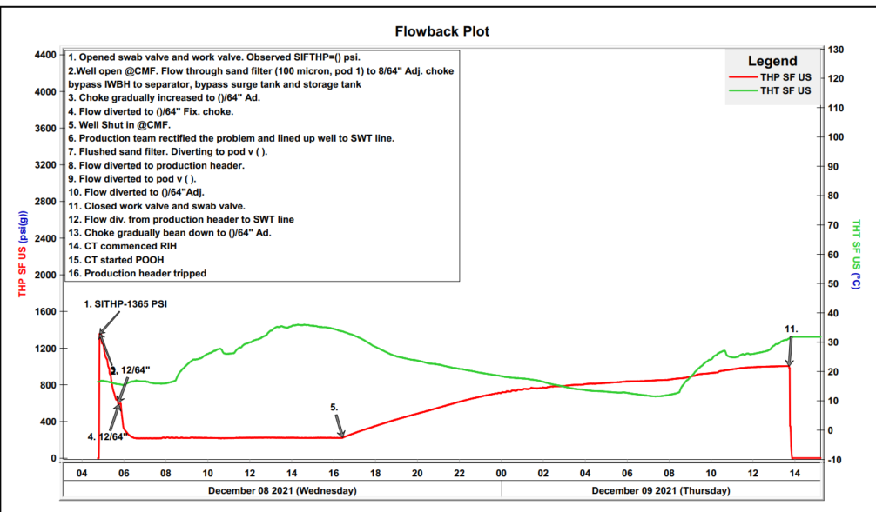
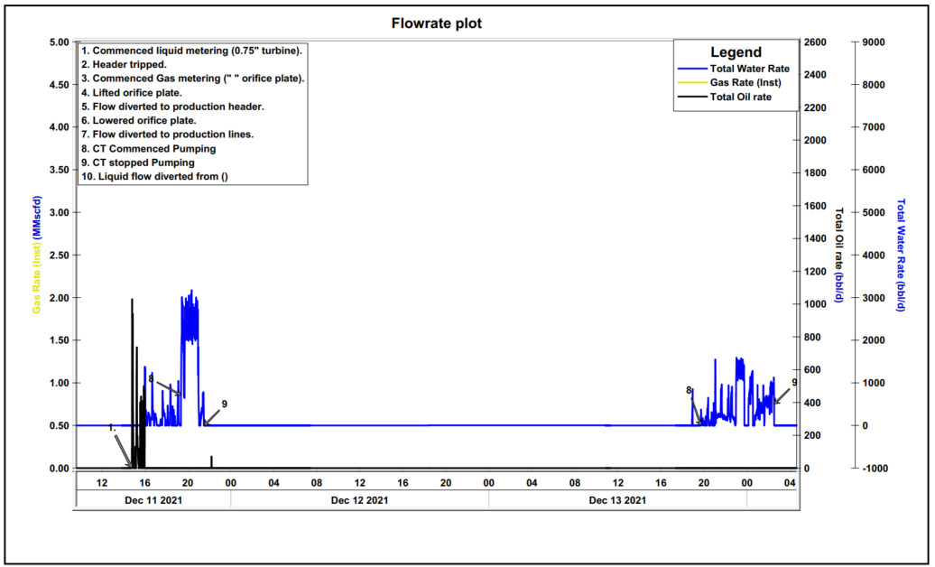

It should be possible to make following changes while graph is displaying live data.
- Zoom in and out
- Change timeline
- Display annotations
Additional features
- Data overwrite option for all the transmitted values should be available.
- Calibration adjustment factor should can be added for each transmitted data
- Audio and visual pop up alarm for individual set value – high and low
- File should be auto saved every 5 mins to ensure none of the data is lost

Reporting Generation
Software should allow to generate the report based on selection of timeline with data interval selected.
The report should consist of option to print following
- Well data captured
- Well history
- Well information
- Sequence of event
- Reporting file
- Graphs based on selection
- Attachments added as per sequence

Operator should click on information required for printing of report and accordingly the report should be printed in PDF. Graph should be pre-saved, and selection of those graphs can be done.

For Well data captured, well history, well information, reporting file & sequence of event option to export the data in .CSV file should be given.

Client Display section
For report display in real time on client desk, option to transmit the acquired data should be given. Software can be installed in customer laptop and client will be able to only read the data transmitted through web. And review the graphs for decision making.

